**Slot: L5+L6 Name: Swaranjana Nayak**

**Date: 02/11/2020 Reg. No.: 19BCE0977**

**LAB FAT**

**Aim:**

To implement and give a solution to given Problem statement and show the output.

**Problem Statement:**

Design a structure laptop with the specification model(dell, HP etc), cost, quantity.  Customer places a order based on the requirement.  Prepare a Bill in the following format

Product Model    Quantity                  Cost

Dell                             2                      1,50,000

HP                               1                      1,00,000

Total cost                                            3,00,000

**Source Code:**

// BATCH 4

// SWARANJANA NAYAK - 19BCE0977

// Design a structure laptop with the specification model(dell, HP etc), cost, quantity.

// Customer places a order based on the requirement.

// Prepare a Bill in the following format

// Product Model    Quantity                  Cost

// Dell                2                      1,50,000

// HP                  1                      1,00,000

// Total cost                                 3,00,000

# include <stdio.h>

# include <stdlib.h>

# include <string.h>

# define N 10

// Struct definition of laptop

typedef struct laptop

{

    char **model;

    int *cost;

    int *quantity;

}Laptop;

enum cost_val{HP = 100000, Dell = 150000, Lenovo = 120000, Acer = 143000};

// Prototyping functions

Laptop *initialize_laptop(Laptop *order, int no_of_items);

int main()

{

    int i, j, no_of_customers = 0, no_of_items, total_cost, value;

    char more;

    Laptop **orders; // an array of orders for multiple customers, if they come.

    orders = (Laptop **)malloc(N * sizeof(Laptop *));

    for(i = 0; i < N; i++)

    {

        *(orders + i) = NULL;

    }

    do

    {

        printf("\nWelcome Customer %d!\n", no_of_customers + 1);

        printf("\nHow many items Laptops are you going to buy?: ");

        scanf("%d", &no_of_items);

        fflush(stdin);

        orders[no_of_customers] = initialize_laptop(orders[no_of_customers], no_of_items);

        total_cost = 0;

        for(i = 0; i < no_of_items; i++)

        {

            printf("What is model name you want for item %d?: ", i + 1);

            fflush(stdin);

            fgets(orders[no_of_customers]->model[i], N, stdin);

            //printf("\n%s", orders[no_of_customers]->model[i]);

            printf("How many laptops of that model do you want?: ");

            scanf("%d", ((*(orders + no_of_customers))->quantity) + i);

            if(strcmp(orders[no_of_customers]->model[i], "HP\n") == 0)

            {

                printf("yes");

                value = 100000;

            }

            else if(strcmp(orders[no_of_customers]->model[i], "Dell\n") == 0)

            {

                value = 150000;

            }

            else if(strcmp(orders[no_of_customers]->model[i], "Lenovo\n") == 0)

            {

                value = 120000;

            }

            else if(strcmp(orders[no_of_customers]->model[i], "Acer\n") == 0)

            {

                value = 143000;

            }

            orders[no_of_customers]->cost[i] = orders[no_of_customers]->quantity[i]  * value;

            total_cost += *(((*(orders + no_of_customers))->cost) + i);

        }

        printf("\nCustomer %d, your bill is:-", no_of_customers + 1);

        printf("\n\nProduct Model    Quantity                  Cost\n");

        printf("-----------------------------------------------------\n");

        for(i = 0; i < no_of_items; i++)

        {

            printf("%s\t\t\t%d\t%d\n", *(((*(orders + no_of_customers))->model) + i), *(((*(orders + no_of_customers))->quantity) + i), *(((*(orders + no_of_customers))->cost) + i));

        }

        printf("-------------------------------------------------------\n");

        printf("Total Cost                                     %d\n\n", total_cost);

        printf("Thank you Customer %d!\n", no_of_customers + 1);

        printf("\n================================================================\n\n");

        fflush(stdin);

        printf("Is there a next customer?: ");

        scanf("%c", &more);

        if(more != 'n')

        {

            no_of_customers++;

            no_of_items = 0;

            total_cost = 0;

        }

    } while (more != 'n');

    return 0;

}

// Function to initialize the laptop struct to hold the information

Laptop *initialize_laptop(Laptop *order, int no_of_items)

{

    int i;

    order = (Laptop *)malloc(sizeof(Laptop));

    //printf("hello");

    order->model = (char **)malloc(no_of_items * sizeof(char*));

    for(i = 0; i < no_of_items; i++)

    {

        *((order->model)+i) = (char *)malloc(N * sizeof(char));

    }

    order->cost  = (int *)malloc(no_of_items * sizeof(int));

    order->quantity = (int *)malloc(no_of_items * sizeof(int));

    return order;

}

**Output:**

**New code**

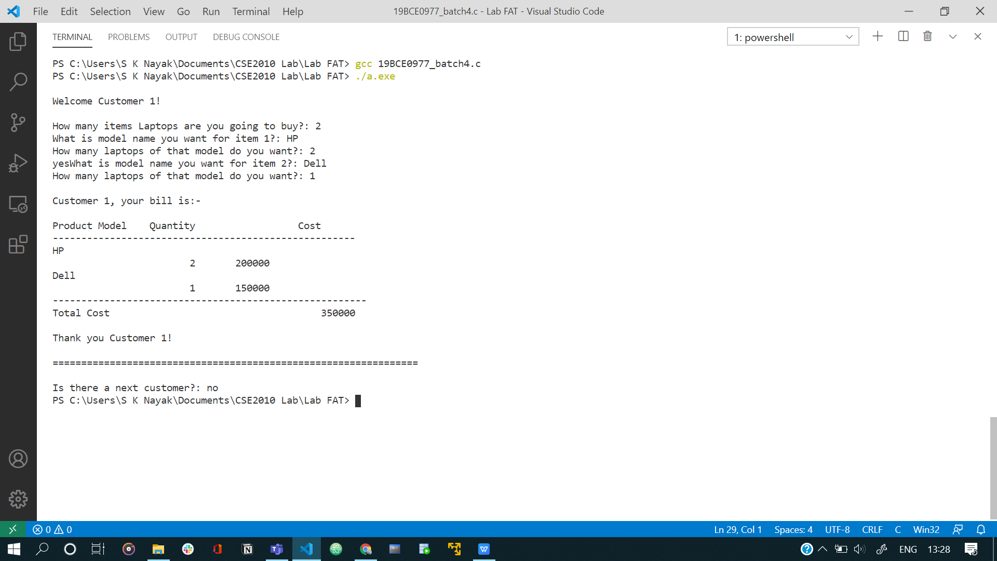

**Old code**

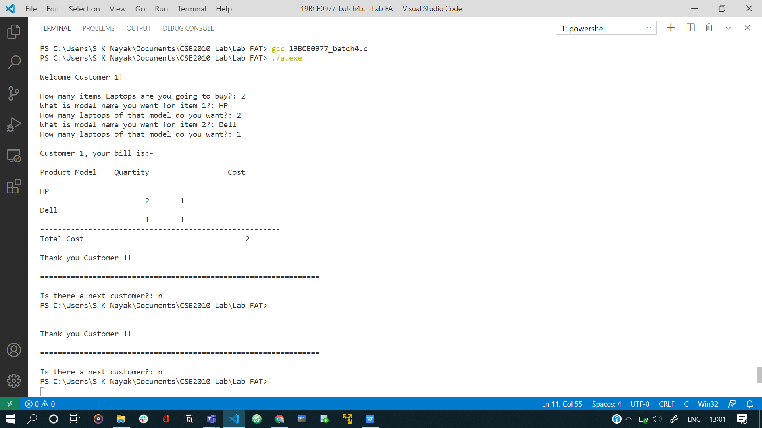

Note: Not recognizing value change. Rest all is correct.